From: https://aronzonijr.medium.com/another-nice-mess-theyve-gotten-us-into-in-ukraine-a71a05d5fa36

By: Al Ronzoni
Jul 5, 2022
7 min read
Listen
Another Nice Mess They’ve Gotten Us into in Ukraine
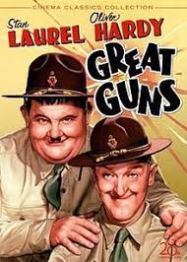
Source: Google Images
The famous catch phrase of the Laurel and Hardy comedy team was “Well here’s another nice mess you’ve gotten me into!” delivered by Stan Laurel to “Ollie” after they had gotten into some kind of slapstick debacle. The current war in Ukraine is certainly no joke but while listening to some recent commentary on the conflict by political scientist John J. Mearsheimer of the University of Chicago, I couldn’t help being reminded of this gem of a comedic line.
Mearsheimer delivered a lecture on “The causes and consequences of the Ukraine war” on June 6th at the European University Institute’s Robert Schuman Centre for Advanced Studies in Fiesole, Italy, near Florence. Mearsheimer’s first argument is that “the United States is principally responsible for causing the Ukraine crisis.” Importantly, he does not deny that Putin started the war and that he alone is responsible for Russia’s horrid conduct in prosecuting it. Nor does Mearsheimer deny that U.S allies bear some responsibility as well, though they largely have followed America’s lead. His key point, however, is that the U.S. “pushed forward policies toward Ukraine that Putin and his colleagues [saw] as an existential threat to their country, a point they have made repeatedly for many years.” More specifically, Mearsheimer points to the U.S.’s “obsession with bringing Ukraine into NATO.” He tells us the Biden administration was unwilling to eliminate that threat through diplomacy and in fact recommitted itself to brining Ukraine into NATO during 2021. He also notes, correctly, that the U.S. and its allies are committed to decisively defeating Russia in Ukraine, so they are not seriously interested in a diplomatic solution to ending the war.
Of course, this means the war could drag on for months if not years with Ukraine, “which has already suffered grievously” experiencing even greater harm. And the longer the war goes on the greater the potential for NATO to get “dragged into the fighting” and for nuclear weapons to be used. Mearsheimer tells us, again correctly, the conventional wisdom in the West is that Putin is solely responsible for the war, that he has imperial ambitions, that he is bent on conquering Ukraine and other countries as well, all for the purpose of creating a Greater Russia that bears at least some resemblance to the Soviet Union. And it doesn’t stop there. Mearsheimer quotes “one scholar” who recently stated that Putin is acting on a “sinister, long-held belief to erase Ukraine from the map of the world.” Mearsheimer’s unnamed scholar is actually Tanisha M. Fazal, Professor of Political Science at the University of Minnesota, who wrote an article entitled The Return of Conquest? Why the Future of Global Order Hinges on Ukraine for the May/June 2022 issue of Foreign Affairs.
Given Putin’s purported goals, it makes perfect sense for Sweden and Finland to join NATO and for the alliance to increase its force levels in Europe. But while this “narrative is repeated over and over in the mainstream media and by virtually every Western leader,” Mearsheimer tells us there is no evidence to support it. For example, some emphasize that Putin has said Ukraine is an artificial state, but Mearsheimer says such “opaque” comments tell us nothing about his reason for going to war. He says the same is true regarding Putin’s statement that the Ukrainians and Russians are “one people with a common history.” Also, it is often pointed out that Putin called the collapse of the Soviet Union “the greatest geopolitical catastrophe of the 20th century.” Of course, Putin also said “Whoever does not miss the Soviet Union has no heart” (a debatable proposition to be sure). Far less quoted, however, is the second part of the statement, “whoever wants it back has no brain.”
Mearsheimer contends that in order to make the case that Putin was bent on conquering all of Ukraine and absorbing it into Russia it is necessary to provide evidence that:
- Putin thought it was a desirable goal
- He thought it was a feasible goal
- He intended to pursue that goal
He tells us there is no evidence in the public record that Putin was either contemplating or intending to put an end to Ukraine as an independent state and to make it part of a Greater Russia. In fact, to the contrary, there is significant evidence that Putin recognizes Ukraine as an independent country. In particular, he [Mearsheimer] cites a lengthy July 2021 article by Putin, which is often cited as evidence of the latter’s “imperial ambitions.” I [author Ronzoni] read the letter myself and in it Putin writes with a lot of very specific detail on the common historical origins the Russian, Belarusian and Ukrainian peoples beginning with the early Medieval state of Kievan Rus (879–1240 AD). Most, if not all, of what he says about the deeply intertwined history of these peoples/nations, as well as their relationship to others like the Mongols, Poles and Lithuanians, is accurate.
Putin also writes about the common literary and cultural heritage of Russians and Ukrainians, exemplified by great writers and poets like, Ivan Kotlyarevsky, Grigory Skovoroda, Taras Schevchenko and Nikolay Gogol, who while ethnically Ukrainian, was also a strong supporter of the Tsarist autocracy and Russian Orthodox Church. But Putin also acknowledges the Tsarist regime’s attempts to suppress the Ukrainian language in the mid-1860s, although he claims this was in response to the 1863–64 “January Uprising” of Poles living under Russian rule, who were attempting to stir up the Ukrainians for their own purposes.
Putin also writes that “modern Ukraine is entirely the product of the Soviet era.” What he means by this is that the present-day territory of Ukraine was shaped over time by the Soviet government as can be seen from this map:
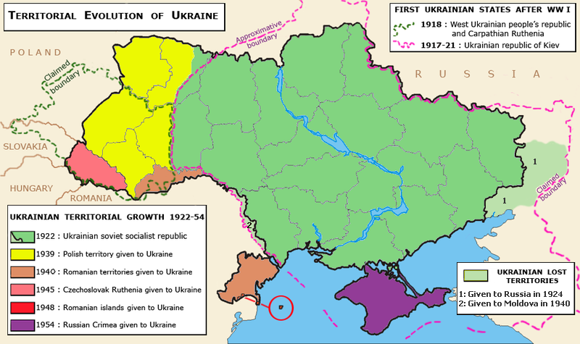
Source: Wikipedia
But this is not the same thing as saying Ukraine is an “artificial state” with no right to exist.
Putin writes further:
You want to establish a state of your own: you are welcome! But what are the terms? I will recall the assessment given by one of the most prominent political figures of new Russia, first mayor of Saint Petersburg Anatoly Sobchak. As a legal expert who believed that every decision must be legitimate, in 1992, he shared the following opinion: the republics that were founders of the Union, having denounced the 1922 Union Treaty, must return to the boundaries they had had before joining the Soviet Union. All other territorial acquisitions are subject to discussion, negotiations, given that the ground has been revoked.
Now, I can certainly understand Ukrainians thinking, “How very gracious of you to give us the go ahead to establish a state of our own! Anatoly Sobchak’s may have an opinion on what territories we are entitled to, but we have our own opinion on that as well.” But despite the crassness of Putin’s statement, it still reinforces Mearsheimer’s point that it doesn’t indicate a desire on his part to “erase Ukraine from the map of the world” as Professor Fazal alleged.
As Mearsheimer notes, another telltale sign that Russia never intended to conquer the whole of Ukraine is the size of the force used in the invasion. It was far too small to vanquish and occupy Ukraine. “In short,” as Mearsheimer says, “Russia did not have the capability to subdue all of Ukraine, much less to conquer other countries.” This fact, now proven beyond the shadow of doubt, should reassuring and a cause for calm on the part of the U.S. and its NATO allies as they deliberate on how to resolve the crisis. But instead, the U.S., NATO and prospective members Sweden and Finland are acting as though they are facing a serious conventional military threat from Russia.
Circling back to the beginning of his lecture, Mearsheimer once again tells us that the “taproot” of the Ukraine war was “the American-led effort to make Ukraine a Western bulwark on Russia’s borders.” The U.S. first embarked on this fool’s errand by announcing it at the 2008 Bucharest Summit. The sinister imperialist Putin was actually invited to the gathering as well because he was not viewed as an imperialist threat at the time in addition to being seen as too weak to do anything about NATO expansion to include Ukraine. Cooler heads in the American foreign policy establishment warned that it would lead to conflict between the U.S./NATO and Russia. One of these was William Burns, currently Director of the CIA, who was then U.S. ambassador to Russia. Mearsheimer reads a portion of a memo Burns wrote to then Secretary of State Condoleezza Rice:
Ukrainian entry into NATO is the brightest of all red lines for the Russian elite, not just Putin. In more than two and a half years of conversations with key Russian players, from knuckle draggers in the dark recesses of the Kremlin to Putin’s sharpest liberal critics, I have yet to find anyone who views Ukraine and NATO as anything other than a direct challenge to Russian interests. NATO would be seen as throwing down the strategic gauntlet, today’s Russia will respond.
There is, of course, one way Putin and Russia do present a real threat to Europe and the United States: It’s arsenal of long-range precision-guided missiles, its ability to strike out at communications satellites, wireless networks, and other command-and-control systems and its possession of the largest nuclear weapons arsenal on the face of the Earth. Each day the war in Ukraine goes on increases the potential for the conflict to escalate into all-out war between NATO, Russia, Belarus, possibly China, and other countries that might get dragged in as well.
It would be something the [world ?] has never experienced before: World War in a 21st century technological and nuclear age.

